**Imitation Learning**

* Imitation Learning, also known as Learning from Demonstration (LfD), is a method of [machine learning](https://deepai.org/machine-learning-glossary-and-terms/machine-learning) where the learning agent aims to mimic human behavior.
* In traditional machine learning approaches, an agent learns from trial and error within an environment, guided by a reward function.
* However, in imitation learning, the agent learns from a dataset of demonstrations by an expert, typically a human.
* The goal is to replicate the expert's behavior in similar, if not the same, situations.

**How Imitation Learning Works**

* Imitation learning involves observing an expert performing a task and learning to imitate those actions.

**The process generally involves three main steps:**

1. **Data Collection:** An expert demonstrates the task to be learned. This could involve controlling a robot arm to pick up objects or driving a car through a course. The actions and decisions of the expert are recorded as data.
2. **Learning:** The collected data is then used to train a machine learning model. The model learns a policy – a mapping from observations of the environment to actions – that tries to replicate the expert's behavior.
3. **Evaluation:** The trained model is tested in the environment to assess how well it performs the task compared to the expert. The goal is to minimize the difference between the expert's performance and the agent's performance.

**There are two main approaches to imitation learning:**

1. **Behavioral Cloning:**

* This is a straightforward approach where the agent directly maps states to actions.
* The model is trained in a [supervised learning](https://deepai.org/machine-learning-glossary-and-terms/supervised-learning) fashion using the state-action pairs from the expert's demonstrations.
* behavioral cloning can suffer from compounding errors – small deviations early in the policy can lead to larger errors later on.

1. **Inverse Reinforcement Learning (IRL):**

* Instead of directly learning the actions, IRL aims to learn the underlying reward function that the expert seems to be maximizing.
* Once the reward function is inferred, [reinforcement learning](https://deepai.org/machine-learning-glossary-and-terms/reinforcement-learning) can be used to learn the policy.
* This approach can generalize better to unseen states but is typically more complex and computationally intensive.

**Applications of Imitation Learning**

Imitation learning has a wide range of applications, particularly in areas where defining a reward function is challenging or where human expertise is valuable:

* **Autonomous Vehicles:** Imitation learning can be used to train self-driving cars by learning from human drivers. It helps in understanding complex maneuvers and driving behavior in real-world scenarios.
* **Robotics:** In robotics, imitation learning helps in teaching robots tasks that are easy for humans but difficult to define programmatically, such as cooking or folding clothes.
* **Game Playing:** Video games and board games often use imitation learning to train [AI agents](https://deepgram.com/ai-glossary/ai-agents) to play at a human level by learning from gameplays of skilled players.
* **Healthcare:** In surgical robotics, imitation learning can assist in learning from expert surgeons to perform delicate operations with robotic assistance.

**Challenges in Imitation Learning**

While imitation learning has shown promise, it also faces several challenges:

* **Data Quality:** The quality of the learned policy is highly dependent on the quality of the demonstrations. Poor demonstrations can lead to ineffective or incorrect behaviors.
* **Distribution Shift:** The agent may encounter states that were not covered in the training demonstrations, leading to uncertain behavior. This is known as the distribution shift problem.
* **Scalability:** Collecting expert demonstrations can be expensive and time-consuming, especially for complex tasks, making it difficult to scale.
* **Generalization:** The ability of the agent to generalize the learned behavior to new situations is a critical challenge, especially in dynamic and unpredictable environments.

**Transfer learning**

* **Transfer learning** is a[**machine learning**](https://www.geeksforgeeks.org/ml-machine-learning/)technique where a model trained on one task is repurposed as the foundation for a second task.
* This approach is beneficial when the second task is related to the first or when data for the second task is limited.
* Leveraging learned features from the initial task, the model can adapt more efficiently to the new task, accelerating learning and improving performance.
* Transfer learning also reduces [overfitting](https://www.geeksforgeeks.org/underfitting-and-overfitting-in-machine-learning/)risk, as the model already incorporates generalizable features useful for the second task.

**Why is Transfer Learning Important?**

Transfer learning is a critical technique in machine learning, offering solutions to key challenges:

1. **Limited Data:** Acquiring extensive labeled data is often challenging and costly. Transfer learning enables us to use pre-trained models, reducing the dependency on large datasets.
2. **Enhanced Performance:** Starting with a pre-trained model, which has already learned from substantial data, allows for faster and more accurate results on new tasks—ideal for applications needing high accuracy and efficiency.
3. **Time and Cost Efficiency:** Transfer learning shortens training time and conserves resources by utilizing existing models, eliminating the need for training from scratch.
4. **Adaptability:** Models trained on one task can be fine-tuned for related tasks, making transfer learning versatile for various applications, from image recognition to natural language processing.

**How Does Transfer Learning Work?**

Transfer learning involves a structured process to leverage existing knowledge from a pre-trained model for new tasks:

1. [**Pre-trained Model**](https://www.geeksforgeeks.org/top-5-pre-trained-models-in-natural-language-processing-nlp/)**:** Start with a model already trained on a large dataset for a specific task. This pre-trained model has learned general features and patterns that are relevant across related tasks.
2. **Base Model:** This pre-trained model, known as the base model, includes layers that have processed data to learn hierarchical representations, capturing low-level to complex features.
3. **Transfer Layers:** Identify layers within the base model that hold generic information applicable to both the original and new tasks. These layers, often near the top of the network, capture broad, reusable features.
4. [**Fine-tuning**](https://www.geeksforgeeks.org/transfer-learning-with-fine-tuning-in-nlp/)**:** Fine-tune these selected layers with data from the new task. This process helps retain the pre-trained knowledge while adjusting parameters to meet the specific requirements of the new task, improving accuracy and adaptability.

**The Block diagram is shown below as follows:**

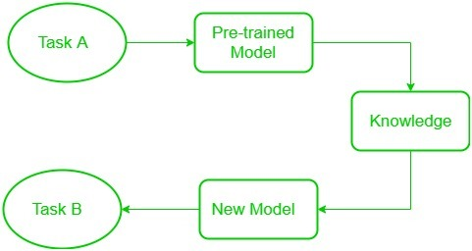

**Transfer Learning**

**Low-level features** learned for task A should be beneficial for learning of model for task B.

**Frozen and Trainable Layers**

In Transfer Learning, two main components help in adapting models effectively: frozen layers and modifiable layers.

1. **Frozen Layers:** These layers from a pre-trained model remain unchanged during fine-tuning. They retain general features learned from the original task, extracting universal patterns from input data.
2. **Modifiable Layers:** These layers are adjusted during fine-tuning to learn task-specific features from the new dataset, allowing the model to meet the new task’s unique requirements.

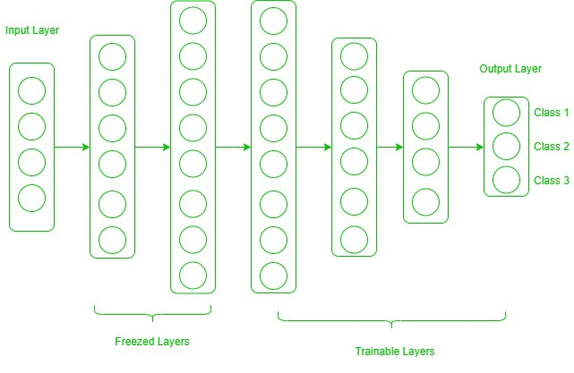

**Deciding Which Layers to Freeze or Modify**

Now, one may ask how to determine which layers we need to freeze, and which layers need to train.

The answer is simple, the more you want to inherit features from a pre-trained model, the more you have to freeze layers.

The extent to which you inherit features from a pre-trained model depends on the size and similarity of the target dataset to the original dataset:

* **Small and Similar Target Dataset:** When the dataset is limited but similar to the base dataset, fine-tuning only a few layers may lead to overfitting. In this case, the last one or two fully connected layers are removed and replaced with a new layer that fits the target classes. The rest of the model is frozen, and only the newly added layers are trained.
* **Large and Similar Target Dataset:** If the target dataset is large and similar, overfitting is less likely. The last fully connected layer is removed, replaced to match the new classes, and the entire model is fine-tuned on the new dataset, preserving the architecture while adapting to the larger dataset.
* **Small and Different Target Dataset:** When the target dataset is small and distinct, the high-level features from the original model are less useful. Here, remove most of the top layers, add new layers to accommodate the target classes, and train from these lower layers onward to fit the unique dataset.
* **Large and Different Target Dataset:** For large and distinct datasets, the model benefits most from removing the final layers and adding new layers tailored to the new task. The entire model is then retrained without frozen layers to ensure complete adaptation.

**Swarm robotics and Collective intelligence**

* Swarm robotics is a field of robotics that uses collective intelligence to design groups of robots that can work together to perform complex tasks.
* The concept of collective intelligence is based on the idea that a group of simple robots can exhibit behaviors that are beyond the capabilities of any individual robot.

Here are some key aspects of swarm robotics and collective intelligence:

* **Inspiration** : Swarm robotics is inspired by the collective behavior of social insects, such as ants, bees, and termites.

* **Decentralized** : Swarm robots work together without centralized control or external infrastructure.

* **Local interactions** : Robots in a swarm communicate and interact locally, sharing information and adapting to changing circumstances.

* **Emergent properties** : The swarm as a whole can exhibit emergent properties, such as self-organization, robustness, and adaptive behavior.

* **Fault tolerance** : Swarm robotics systems are designed to be fault tolerant, scalable, and flexible.

* **Applications** : Swarm robotics can be used for tasks such as demining, search and rescue, planetary or underwater exploration, and surveillance

**An overview of emerging robotic industry trends**

Today, with the AI revolution propelling robots to new heights of functionality and human-robot interaction, robots already play pivotal roles in healthcare, surgery, transportation, and even space exploration.

Let us explore some emerging trends of robotic innovation and applications that might dominate the industry in the coming years.

Artificial intelligence and machine learning

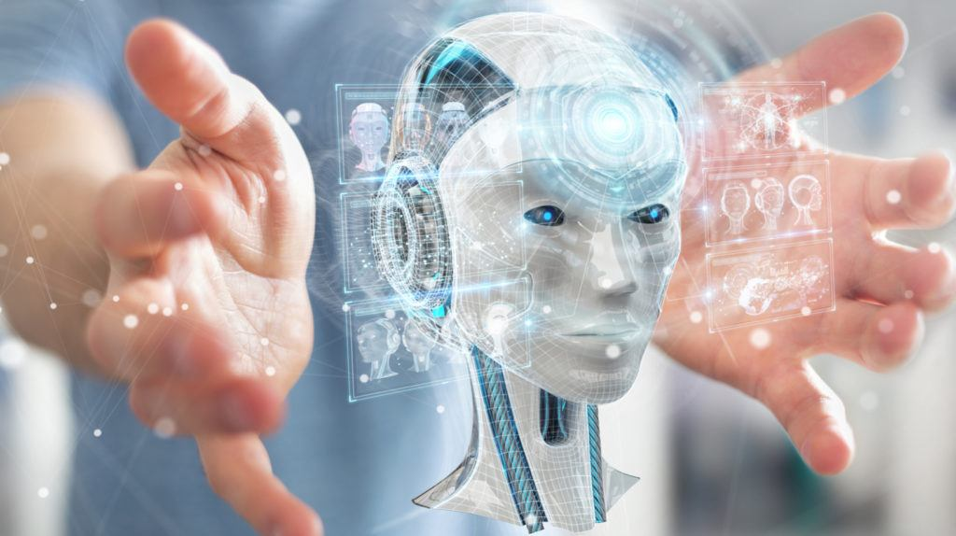

At the forefront of technological advancement, Artificial Intelligence (AI) and Machine Learning (ML) emerge as the dazzling stars. Businesses across various industries are leveraging them to enhance decision-making, automate processes, and gain actionable insights from vast datasets.

* AI-driven personalization is transforming customer experiences, from e-commerce recommendations to content curation on social media platforms.
* In healthcare, AI is accelerating drug discovery by enabling more accurate diagnoses; and autonomous vehicles and smart homes are becoming increasingly commonplace, thanks to AI and ML again.

The growing demand for AI experts and expanding research and development in the field highlights the enduring trend of AI and ML signifying that it is here to stay.

Collaborative robots

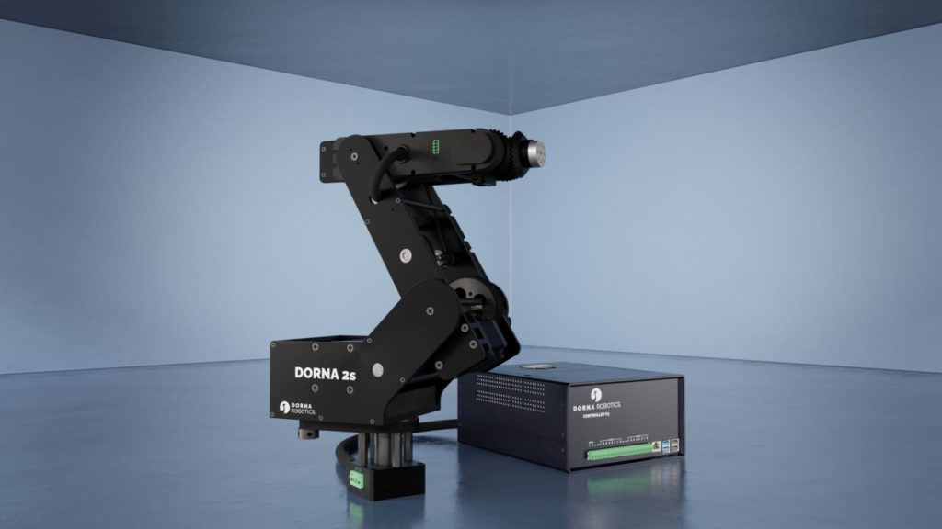

Collaborative robots, often called cobots, are a thriving trend in the automation landscape, and their significance continues to unfold. They’re designed to work alongside humans enhancing their efficiency, safety, and flexibility in industrial processes.

* A particular reason that Cobots are experiencing a surge in their application, especially among small and medium-sized enterprises, is their cost-effectiveness and ease of integration.
* This trend is driven by a widespread industrial need for adaptable and responsive automation solutions to collaborate with human workers on various tasks, from assembly to quality control.
* As companies seek to optimize their operations and maintain a competitive edge, collaborative robots emerge as a perfect opportunity, shaping the future of work across multiple sectors.

Dorna is a leading provider of [**collaborative robots**](https://dorna.ai/robots/) that are recognized for their efficiency as well as safety around workers in industrial settings. [**Book a demo**](https://dorna.ai/book-a-demo/) to explore its application in your warehouse processes.

**Soft robotics**

Centered around creating robots with flexible, pliable materials that mimic natural organisms, soft robotics is a booming trend in robotics. This innovative approach allows robots to perform tasks with a human-like touch and adaptability, making them well-suited for healthcare, manufacturing, and other sectors.

* The trend is fueled by the need for robots that can safely interact with humans and handle delicate items in environments where traditional rigid robots may not be suitable.
* As materials and manufacturing techniques advance, soft robotics too is finding applications in diverse fields, promising a future of more versatile and adaptable automation solutions than before.

**Swarm robotics**

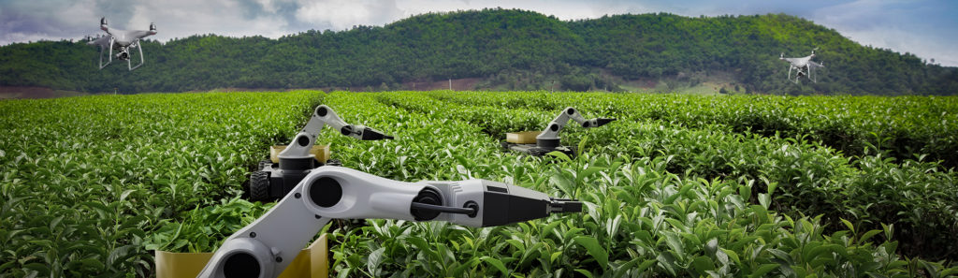

A field inspired by the collective behavior of social insects, Swarm robotics is gaining significant traction in the robotics and automation industry. It involves multiple, often simple robots working together in a coordinated manner to achieve complex tasks.

* Its popularity is largely driven by its potential to revolutionize various applications, from environmental monitoring to agriculture and logistics.
* Swarm robotics offers advantages such as redundancy, adaptability, and robustness and is considered a solution to challenges like disaster response and precision agriculture.
* Further advancements in coordination algorithms and communication technologies can proceed to make it a key player in the automation landscape.

**Autonomous vehicles**

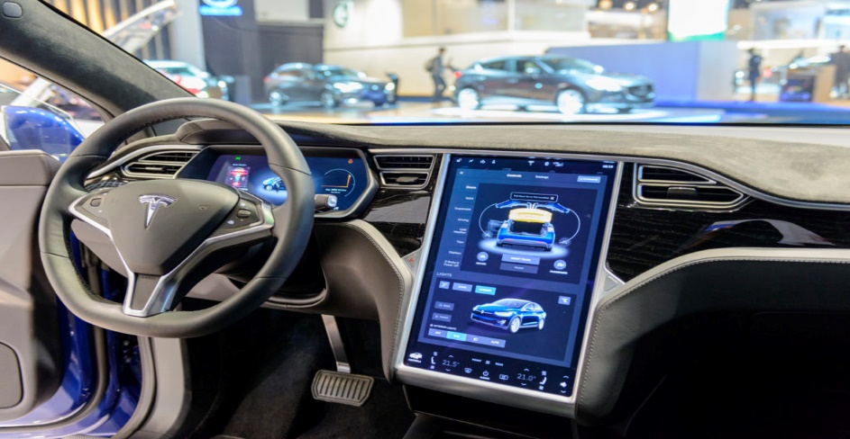

The urban landscape is continuously being reshaped by autonomous vehicles. Thanks to the advancements in artificial intelligence, sensor technology, and connectivity, self-driving cars and drones are becoming more and more popular.

* The trend appears almost innate keeping in view today’s essential urban needs today to enhance safety, reduce traffic congestion, and increase transportation efficiency.
* Major tech companies and automakers are heavily investing in autonomous vehicle development, leading to innovations in ride-sharing services and last-mile delivery solutions.
* As regulations evolve to accommodate these technologies, autonomous vehicles are set to transform the way we transport people and goods.

**Medical robotics**

It is not one but two significant sectors that medical robotics is rapidly revolutionizing through the innovations it offers in healthcare and surgery.

* With the goal of improving precision and patient outcomes, robots are being used to assist surgeons in intricate procedures, including minimally invasive surgeries and diagnostics.
* They facilitate less invasive treatments and more accurate diagnoses, driving forward research and development in the medical field.
* Robots are also enhancing healthcare access through telemedicine and remote monitoring.

With ongoing technological advancements, they’re set to reshape the way we approach medical care and healthcare procedures.

**Humanoid robots**

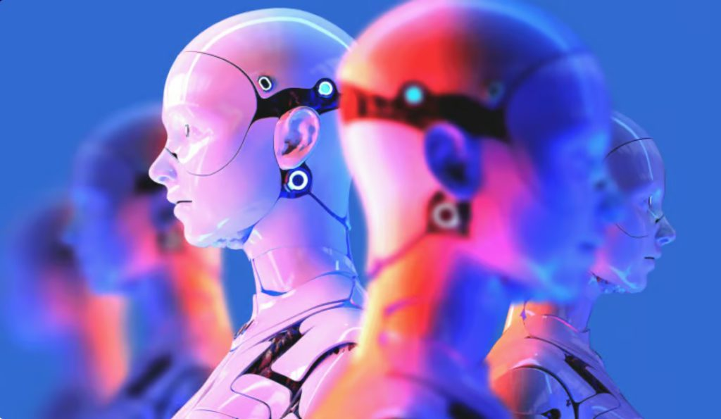

Perhaps the most engaging and closely aligned with the realm of science fiction imagination of robots is the humanoid.

* These robots are designed to mimic human appearance and movements and are currently gaining traction as a prominent trend in the robotics and automation industry.
* Robots, such as Sophia and ASIMO, are increasingly used in applications ranging from customer service to education and companionship for the elderly.
* The trend is propelled by the desire to create machines capable of human-like interaction and a growing interest in social robotics.

Beyond their utility in the aforementioned sectors, they also raise profound questions about the future of human-robot relationships.

**Augmented reality**

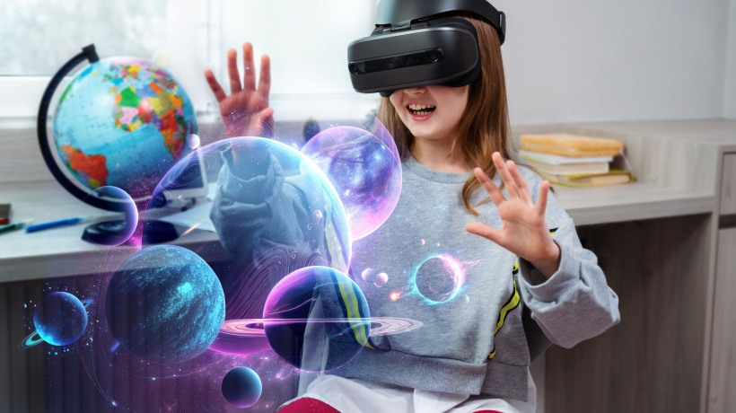

AR or Augmented reality is another emerging trend that is gaining momentum in its application, and revolutionizing the way we interact with technology. AR enhances our real-world perception by overlaying digital information onto our physical surroundings.

* This technology finds applications in gaming, education, training, navigation, and numerous industrial sectors.
* It bridges the gap between the virtual and physical realms, enhancing human experiences and increasing productivity.
* As AR devices, like smart glasses, become more accessible and sophisticated, their adoption continues to grow.

The trend is fueled by the potential for more immersive and intuitive human-machine interactions, creating a dynamic and promising future for AR within the robotics and automation landscape.

**Industry 4.0 and smart manufacturing**

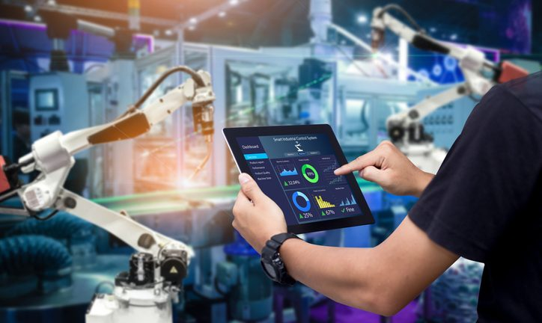

Industry 4.0, known as the fourth industrial revolution, is all about transforming manufacturing and automation by leveraging IoT, big data, and advanced automation.

* It envisions interconnected systems and data-driven decision-making for efficient and flexible manufacturing where IoT devices collect real-time data that is analyzed through big data analytics.
* Smart manufacturing is a key outcome of this, where companies like BMW and Volkswagen use IoT-connected robots for real-time adaptability, boosting efficiency and reducing downtime.